- Create a Flask application with an /api route. When this route is accessed, it should return a JSON list. The data should be stored in a backend file, read from it, and sent as a response.
- Command and Explanation mention below for Flask application with an /api route.
#imports Flask to create the web application and render_template to load an HTML file.
from flask import Flask, render_template

#imports the datetime module, which is used to get the current day and time.
from datetime import datetime

#creates an instance of the Flask application.
app = Flask(__name__)

#defines a route named /api. When a user visits this URL, the home() function is executed.
@app.route('/api')
def home():

#gets the current day (for example, Monday, Tuesday).
day_of_week=datetime.today().strftime('%A')

#gets the current time in hours, minutes, and seconds
current_time=datetime.now().strftime('%H:%M:%S')

#loads the index.html file and sends the values of day_of_week and current_time to the #HTML template so they can be displayed using {{ }}.
return render_template ('index.html',day_of_week=day_of_week,current_time=current_time)

#starts the Flask development server.
#debug=True helps during development by automatically reloading the app and showing errors.
if __name__ == '__main__':
app.run(debug=True)
- Screenshot mention below.
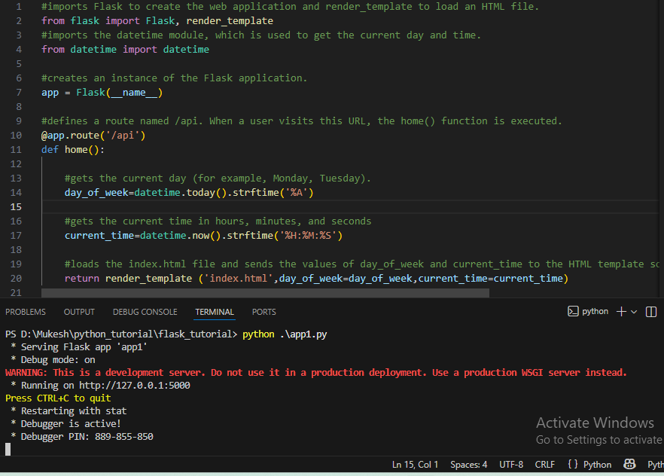

- HTML file for json data.
<!DOCTYPE html>
<html lang="en">
<head>
<meta charset="UTF-8">
<meta name="viewport" content="width=device-width, initial-scale=1.0">
<title>Sign Up Form</title>
</head>
<body>
<p>Hi welcome to the page</p>
<p>Today is a {{ day_of_week }}</p>
<p>The Time is {{ current_time }}</p>
<p>JSON LIST <br> "Python" <br> "Flask" <br> "Django"</p>
</body>
<style>
body {
background-color: aquamarine;
}
p{
text-align: center;
font-size: 30;
font-family: 'Courier New', Courier, monospace;
color: black;
}
</style>
</html>
- Output ScreenShot.
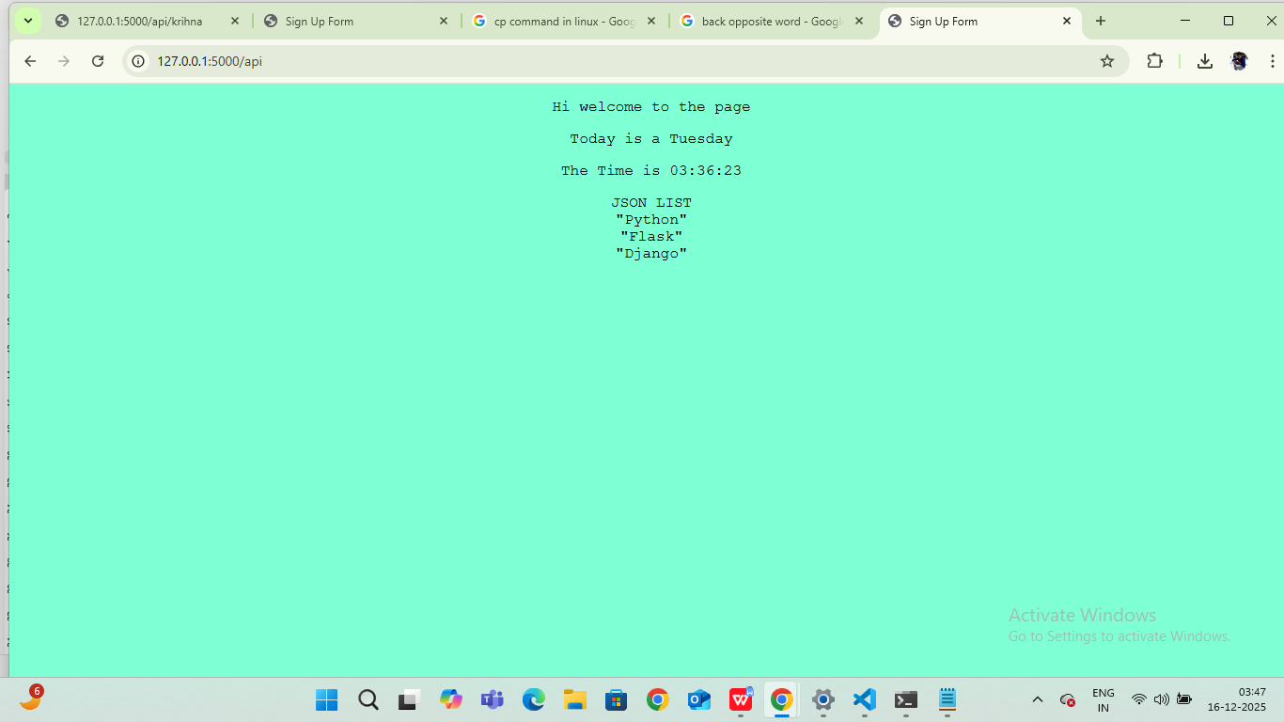

2. Create a form on the frontend that, when submitted, inserts data into MongoDB Atlas. Upon successful submission, the user should be redirected to another page displaying the message "Data submitted successfully". If there's an error during submission, display the error on the same page without redirection.

- Install required packages.
pip install flask pymongo

- Flask Backend
from flask import Flask, render_template, request, redirect, url_for
from pymongo import MongoClient

app = Flask(__name__)

# MongoDB Atlas connection
client = MongoClient("YOUR_MONGODB_ATLAS_CONNECTION_STRING")
db = client["testdb"]
collection = db["users"]

@app.route("/", methods=["GET", "POST"])
def form():
error = None

if request.method == "POST":
try:
name = request.form["name"]
email = request.form["email"]

collection.insert_one({
"name": name,
"email": email
})

return redirect(url_for("success"))

except Exception as e:
error = str(e)

return render_template("form.html", error=error)

@app.route("/success")
def success():
return render_template("success.html")

if __name__ == "__main__":
app.run(debug=True)

- Frontend Form
<!DOCTYPE html>
<html>
<head>
<title>Submit Form</title>
</head>
<body>

<h2>Submit Your Data</h2>

<form method="post">
<input type="text" name="name" placeholder="Name" required><br><br>
<input type="email" name="email" placeholder="Email" required><br><br>
<button type="submit">Submit</button>
</form>

{% if error %}
<p style="color:red;">Error: {{ error }}</p>
{% endif %}

</body>
</html>

- Success Page
<!DOCTYPE html>
<html>
<head>
<title>Success</title>
</head>
<body>

<h2>Data submitted successfully</h2>

</body>
</html>

Submission Guidelines -: Attach Screenshots or command along with explanation and submit in doc(google doc or microsoft doc) format also attach github repo link

